ドボンレポート

|  |  |
| --- | --- |
| 2枚のとき | |
| 出した数 | ドボンされる確率[%] |
| 1 | 33.33 |
| 2 | 24.36 |
| 3 | 20.51 |
| 4 | 20.51 |
| 5 | 16.67 |
| 6 | 17.95 |
| 7 | 14.10 |
| 8 | 15.38 |
| 9 | 14.10 |
| 10 | 14.10 |
| 11 | 11.54 |
| 12 | 14.10 |
| 13 | 10.26 |

|  |  |
| --- | --- |
| 3枚のとき | |
| 出した数 | ドボンされる確率[%] |
| 1 | 0.00 |
| 2 | 0.00 |
| 3 | 0.02 |
| 4 | 0.10 |
| 5 | 0.23 |
| 6 | 0.40 |
| 7 | 0.63 |
| 8 | 1.00 |
| 9 | 1.21 |
| 10 | 1.55 |
| 11 | 2.09 |
| 12 | 2.52 |
| 13 | 3.07 |

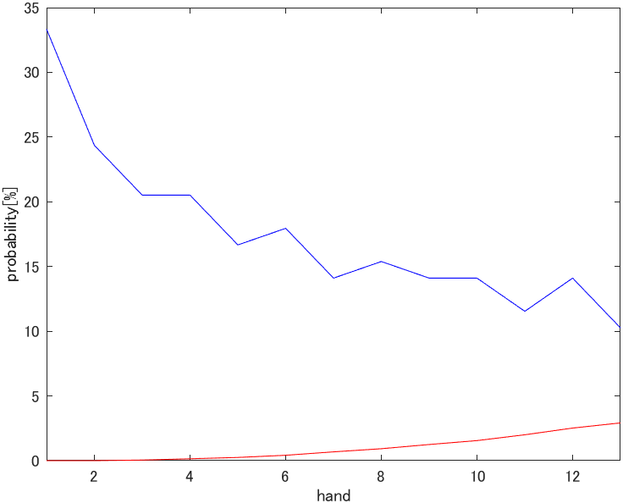

|  |  |  |  |  |  |  |  |  |  |  |  |  |  |
| --- | --- | --- | --- | --- | --- | --- | --- | --- | --- | --- | --- | --- | --- |
|  | 1 | 2 | 3 | 4 | 5 | 6 | 7 | 8 | 9 | 10 | 11 | 12 | 13 |
| 1 | 72.5 | 56.0 | 57.1 | 58.2 | 60.4 | 60.4 | 62.6 | 61.5 | 63.7 | 62.6 | 64.8 | 63.7 | 65.9 |
| 2 | 56.0 | 81.3 | 68.1 | 68.1 | 69.2 | 69.2 | 70.3 | 71.4 | 71.4 | 71.4 | 72.5 | 72.5 | 73.6 |
| 3 | 57.1 | 68.1 | 83.5 | 71.4 | 71.4 | 70.3 | 73.6 | 73.6 | 73.6 | 73.6 | 75.8 | 74.7 | 76.9 |
| 4 | 58.2 | 68.1 | 71.4 | 84.6 | 73.6 | 72.5 | 73.6 | 73.6 | 74.7 | 75.8 | 75.8 | 75.8 | 76.9 |
| 5 | 60.4 | 69.2 | 71.4 | 73.6 | 86.8 | 75.8 | 76.9 | 75.8 | 76.9 | 75.8 | 79.1 | 76.9 | 80.2 |
| 6 | 60.4 | 69.2 | 70.3 | 72.5 | 75.8 | 85.7 | 76.9 | 75.8 | 75.8 | 76.9 | 76.9 | 75.8 | 78.0 |
| 7 | 62.6 | 70.3 | 73.6 | 73.6 | 76.9 | 76.9 | 89.0 | 79.1 | 79.1 | 79.1 | 81.3 | 79.1 | 82.4 |
| 8 | 61.5 | 71.4 | 73.6 | 73.6 | 75.8 | 75.8 | 79.1 | 87.9 | 79.1 | 78.0 | 79.1 | 79.1 | 80.2 |
| 9 | 63.7 | 71.4 | 73.6 | 74.7 | 76.9 | 75.8 | 79.1 | 79.1 | 89.0 | 80.2 | 81.3 | 78.0 | 82.4 |
| 10 | 62.6 | 71.4 | 73.6 | 75.8 | 75.8 | 76.9 | 79.1 | 78.0 | 80.2 | 89.0 | 82.4 | 79.1 | 81.3 |
| 11 | 64.8 | 72.5 | 75.8 | 75.8 | 79.1 | 76.9 | 81.3 | 79.1 | 81.3 | 82.4 | 91.2 | 82.4 | 84.6 |
| 12 | 63.7 | 72.5 | 74.7 | 75.8 | 76.9 | 75.8 | 79.1 | 79.1 | 78.0 | 79.1 | 82.4 | 89.0 | 83.5 |
| 13 | 65.9 | 73.6 | 76.9 | 76.9 | 80.2 | 78.0 | 82.4 | 80.2 | 82.4 | 81.3 | 84.6 | 83.5 | 92.3 |

